**SNIA – DOCUMENTATION**

**Basic System requirements :::**

* Ubuntu 16.04 LTS
* 4 GB RAM

**Installation Steps::**

1 Check for any updates in ubuntu

* sudo apt-get update

2. Install python 2.7 version

* sudo apt-get install python

3. Install pip with python 2.7

* sudo apt-get install python-pip

4. Once check for python and pip versions to check whether we installed correct versions

* Python --version
* Pip -V (In python 2.7 dist packages)

5. Create virtual environment with python 2.7 by following the steps below

To install Python’s virtual environment

1. sudo apt-get install virtualenv
2. create a directory named python-environments
3. mkdir python-env
4. cd python-env
5. virtualenv -p python <virtualenv name>

6) Activate virtual environment (see below figures)

* source <virtualenv name>/bin/activate
* To deactivate virtual environment deactivate

FIG:1

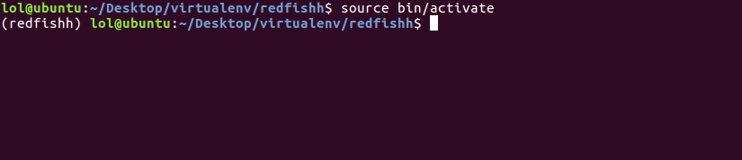

FIG:2

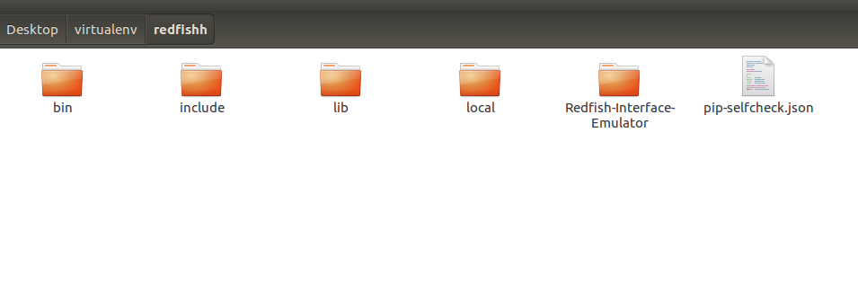

The above figure shows redfish directory is placed in virtualenv installation directory.

**Swordfish Installation Steps:**

1. Create an installation directory
2. Clone the Redfish-interface-emulator files into the installation directory (above figure:2)

git clone <https://github.com/DMTF/Redfish-Interface-Emulator.git>

1. Clone the swordfish-Api-emulator files into Ubuntu (any folder outside installation directory)

git clone <https://github.com/SNIA/Swordfish-API-Emulator.git>

1. Copy “**swordfish-Api-emulator”** files to” **Redfish-interface-emulator** “files which are as follows.

After copying **“**Swordfish-API-Emulator **“** Now we have Two directories in “/api_emulator”

* + - Redfish
    - Swordfish

Move all the files from **“swordfish “**Directory to **“redfish”** directory, and remove the swordfish directory.

Fig:3

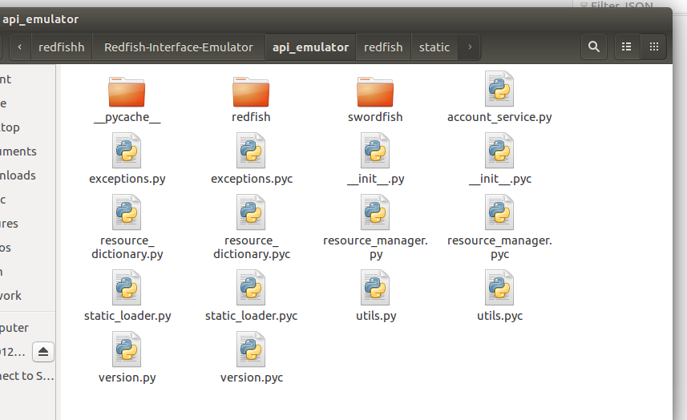

Fig:4

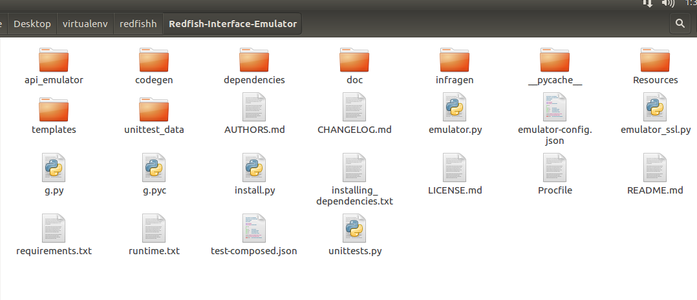

Fig:5:

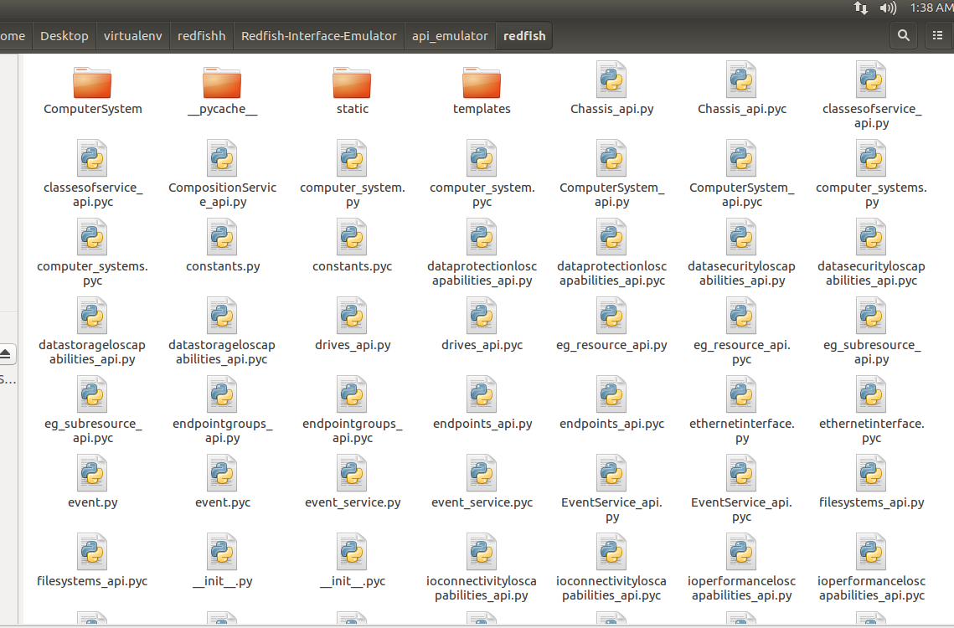

**Install Dependencies:**

After copying the files Install all the dependencies and modules needed by Redfish-Interface-emulator and Swordfish-Api-Emulator by running following command

* **“** python -m pip install setuptools markupsafe itsdangerous flask aniso8601 pytz flask_httpauth requests flask_restful StringGenerator urllib3 six **”**

(OR)

* Open installing_dependencies.txt file and run all the commands individually.

(OR)

* Install dependencies in requirements.txt sudo pip install -r requirements.txt

After completing all the above steps, the Swordfish API Emulator should be fully installed, and it should be possible to run it by entering

**“** python emulator.py **”**

**Windows Installation Steps:**

**Installation Steps::**

Install python 2.7 in windows :

* <https://www.python.org/ftp/python/2.7.14/python-2.7.14.msi>
* After installing python2.7 ,open command prompt and navigate to your python installation directory (default C:\Python27).Type python form this location.

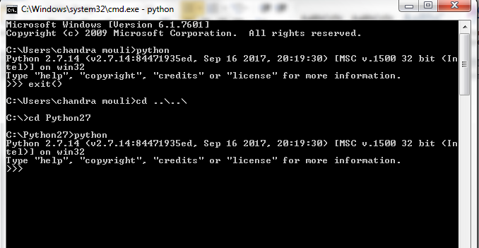

* The above step can be done by adding python installation path to windows ”ENVIRONMENT VARIABLE”.
* Go to My Computers – properties will open system properties. Open advanced tab
* On System Properties / Advanced tab click Environment Variables to open User and System Variables.
* Create a new System Variable named Variable name: PYTHON_HOME and Variable value: c:\Python27 (or whatever your installation path was)(See below FIG :2)
* Find the system variable called Path and click Edit (See below FIG:1)
* Add the following text to the end of the Variable value:;%PYTHON_HOME%\;%PYTHON_HOME%\Scripts\

**Fig:1**

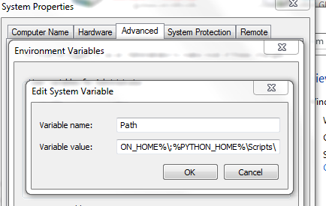

**Fig 2:**

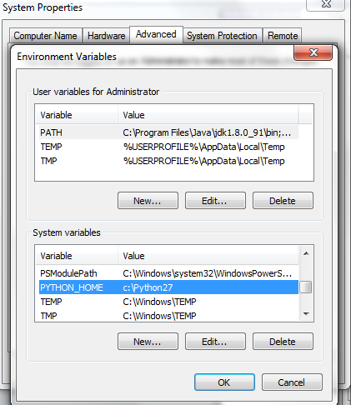

PIP Install:

* 1. Download get-pip.py to your local computer.
* <https://bootstrap.pypa.io/get-pip.py>
  1. Open a command prompt window and navigate to the folder containing get-pip.py.
  2. Then run “python get-pip.py”

After installing python and pip ,follow the “**Swordfish Installation Steps “**Copy “**swordfish-Api-emulator**” files to” **Redfish-interface-emulator**”.

Now run the following commands to install all the dependencies and run emulator

* **Pip install –r requiremants.txt**
* **Python emulator.py**